**HYPERVISOR**

1. Which type of Hypervisor is shown in the following figure?  
[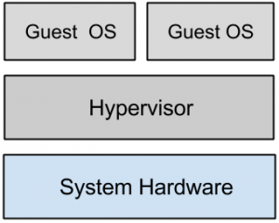](https://www.sanfoundry.com/wp-content/uploads/2015/10/cloud-computing-questions-answers-hypervisors-1-q1.png)  
a) Type 1  
b) Type 2  
c) Type 3  
d) All of the mentioned  
View Answer

Answer: a  
Explanation: A hypervisor running on bare metal is a Type 1 VM or native VM.

2. Point out the wrong statement.  
a) Load balancing virtualizes systems and resources by mapping a logical address to a physical address  
b) Multiple instances of various Google applications are running on different hosts  
c) Google uses hardware virtualization  
d) All of the mentioned  
View Answer

Answer: c  
Explanation: Google performs server load balancing to distribute the processing load and to get high utilization rates.

3. Which of the following is another name for the system virtual machine?  
a) hardware virtual machine  
b) software virtual machine  
c) real machine  
d) none of the mentioned  
View Answer

Answer: a  
Explanation: Some virtual machines are designed to run only a single application or process and are referred to as process virtual machines.

4. Which of the following provide system resource access to virtual machines?  
a) VMM  
b) VMC  
c) VNM  
d) All of the mentioned  
View Answer

Answer: a  
Explanation: VMM is another name for Hypervisor.

5. Point out the correct statement.  
a) A virtual machine is a computer that is walled off from the physical computer that the virtual machine  
is running on  
b) Virtual machines provide the capability of running multiple machine instances, each with their own operating system  
c) The downside of virtual machine technologies is that having resources indirectly addressed means there is some level of overhead  
d) All of the mentioned  
View Answer

Answer: d  
Explanation: This makes virtual machine technology very useful for running old versions of operating systems, testing applications in what amounts to a sandbox.

6. An operating system running on a Type ______ VM is full virtualization.  
a) 1  
b) 2  
c) 3  
d) All of the mentioned  
View Answer

Answer: a  
Explanation: Because it is a complete simulation of the hardware that it is running on.

7. Which of the following is Type 1 Hypervisor?  
a) Wind River Simics  
b) Virtual Server 2005 R2  
c) KVM  
d) LynxSecure  
View Answer

Answer: d  
Explanation: Type 1 VMs have no host operating system because they are installed on a bare system.

8. Which of the following is Type 2 VM?  
a) VirtualLogix VLX  
b) VMware ESX  
c) Xen  
d) LynxSecure  
View Answer

Answer: c  
Explanation: Xen is used by Amazon Web Services to provide Amazon Machine Instances (AMIs).

9. Which of the following will be the host operating system for Windows Server?  
a) VirtualLogix VLX  
b) Microsoft Hyper-V  
c) Xen  
d) All of the mentioned  
View Answer

Answer: b  
Explanation: Type 2 virtual machines are installed over a host operating system.

10. Which of the following should be placed in second lowermost layer for the following figure?  
[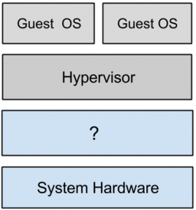](https://www.sanfoundry.com/wp-content/uploads/2015/10/cloud-computing-questions-answers-hypervisors-1-q10.png)  
a) Host Operating System  
b) Software  
c) VM  
d) None of the mentioned  
View Answer

Answer: a  
Explanation: Examples of Type 2 Virtual Machine Monitors are Containers, KVM, Microsoft Hyper V and Parallels Desktop for Mac.

11. What does the following figure represent?  
[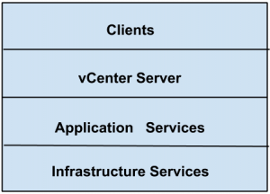](https://www.sanfoundry.com/wp-content/uploads/2015/10/cloud-computing-test-q1.png)  
a) vSquare cloud infrastructure  
b) vCube cloud infrastructure  
c) vSphere cloud infrastructure  
d) None of the mentioned  
View Answer

Answer: c  
Explanation: vSphere is the branding for a set of management tools and a set of products previously labeled VMware Infrastructure.

12. Point out the wrong statement.  
a) Some hypervisors are installed over an operating system and are referred to as Type 2 or hosted VM  
b) All CPUs support virtual machines  
c) On a Type 2 VM, a software interface is created that emulates the devices with which a system would normally interact  
d) All of the mentioned  
View Answer

Answer: b  
Explanation: Not all CPUs support virtual machines and many that do require that you enable this support in the BIOS.

13. Which of the following type of virtualization is found in hypervisor such as Microsoft’s Hyper-V?  
a) paravirtualization  
b) full virtualization  
c) emulation  
d) none of the mentioned  
View Answer

Answer: a  
Explanation: It is the host operating system that is performing the I/O through a para-API.

14. In _______ the virtual machine simulates hardware, so it can be independent of the underlying system hardware.  
a) paravirtualization  
b) full virtualization  
c) emulation  
d) none of the mentioned  
View Answer

Answer: c  
Explanation: A guest operating system using emulation does not need to be modified in any way.

15. Point out the wrong statement.  
a) Full virtualization requires that the host operating system provide a virtual machine interface for the guest operating system and that the guest access hardware through that host VM  
b) Guest operating systems in full virtualization systems are generally faster than other virtualization schemes  
c) A process virtual machine instantiates when a command begins a process  
d) All of the mentioned  
View Answer

Answer: a  
Explanation: An operating system running as a guest on a paravirtualization system must be ported to work with the host interface.

16. In a ____________ scheme, the VM is installed as a Type 1 Hypervisor directly onto the hardware.  
a) paravirtualization  
b) full virtualization  
c) emulation  
d) none of the mentioned  
View Answer

Answer: b  
Explanation: All operating systems in full virtualization communicate directly with the VM hypervisor.

17. Which of the following operating system support operating system virtualization?  
a) Windows NT  
b) Sun Solaris  
c) Windows XP  
d) Compliance  
View Answer

Answer: b  
Explanation: This type of virtualization creates virtual servers at the operating system or kernel level.

18. Which of the following is a service that aggregates servers into an assignable pool?  
a) VMware vStorage  
b) VMware vNetwork  
c) VMware vCompute  
d) Application services  
View Answer

Answer: c  
Explanation: VMware vSphere is a management infrastructure framework that virtualizes system, storage, and networking hardware to create cloud computing infrastructures.

19. _________ is a service that creates and manages virtual network interfaces.  
a) VMware vStorage  
b) VMware vNetwork  
c) VMware vCompute  
d) Application services  
View Answer

Answer: b  
Explanation: VMware vStorage is a service that aggregates storage resources into an assignable pool.

20. Which of the following allows a virtual machine to run on two or more physical processors at the same time?  
a) Virtual SMP(symmetric muti processing)  
b) Distributed Resource Scheduler  
c) vNetwork Distributed Switch  
d) Storage VMotion  
View Answer

Answer: a  
Explanation: The virtualization layer that abstracts processing, memory, and storage uses the VMware ESX or ESXi virtualization server.